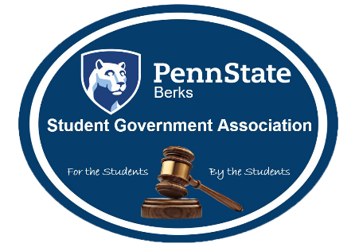
Student Government Association
Meeting Minutes
September 13th, 2017

Call to order:
- 12:15PM
(Duffy takes the attendance)
Approval of minutes:
Taylor (Honors Club): So moves.
Wes (Volley Ball): So second.
No discussion/ opposed/ abstentions
Approval of agenda:
Taylor (Honors Club): So moves
Miguel (DECA): So second
No discussion/ opposed/ abstentions
Old Business:
Alex(VP): Thank you everyone that show up to club training, please fill out the survey to let us know what to improve. The adopt a trail, we voted last week will have the first clean up on October 6th at 5:15pm-6:30pm, you must sign up by October 3rd by emailing mah629. This will also count as a community service event. Hope to see you all there. We voted in clubs last week, congradulations on those clubs getting accepted. Those new clubs have 2 weeks to submit a budget, by Monday Septmber 25th at Campus Life by 5pm. Also we had our class reps give their presentations last week. This week we will vote on them.
New Business:
Alex(VP): We will be voting on class reps today. We will be using ballots, you choose who you want by completing the ballot. These are the reps again freshmen: Tahj, Elina (no show), Jiani, Polly, Talyor, and John. Sophomore class is Brooke, junior Robert. There is currently no senior class rep but we encourage people to run for this position. When you finish choosing your reps please leave it on the tables faced down. We will collect them at the end of the meeting. Next is hurricane disaster relief, I know it has come up before so we have had some discussions on what to do. Res life will host an event.
Duffy: Residence Life is sponsoring an event which is Pie your professor. We will throwing pies at the professors and all the money will go to disaster relief. The event will take place September 22nd from 10AM-6PM. The contact person is Shelby Jefferson sfj5358. Pies will be $5 for a student for $10 for a professor, it will also take place in Perkins Plaza.
Alex(VP): SGA will be doing their fundraiser on Saturday of homecoming. We will have the clubs give a small charge for the games and those funds will go to the disaster relief. Also please have a prize to give away since they are paying for the game. If your club did not sign up for the club fair yet please talk to Lindsay Tucker. Next is DACA, DACA gives certain rights to immigrants in relation to schooling without the worry of deportation. DACA does not give a permanent status, we are encouraging all our students to reach out to their congressmen to aid them in their voting. To students who have been affected by DACA we are working to aid you. Please contact Teri, Mrs. O or Maria Tonocco for aid.
Open Forum:
Nothing
Staff Reports:
Aymed: September 20th is unity day, we need clubs to sign up, once you are signed up and have the list of supplies. Email the list of supplies to Mrs. O.
Alex(VP): Next week we will have a shortened meeting next week for this event.
Cam: The public relations chairs are opening a new club for video editing and general editing.
Argynesse: People who want to join we are going to produce content for SGA as well as the club.
Cam: Our reach out meeting is September. 18th 12:15pm-1:15pm in Thun room 145. Here is another link for some more information, cam.myportfolio.,com.
Chaz: Yesterday I went to University Park for the senate meeting. We discussed DACA, and president Barron wanted to ensure PSU is a learning environment. Also that Penn State wants freedom of speech but no riots.
Nicollete: Cherry wine program, various people will be involved it will be a way to give information of sexual assault. We are looking for some clubs to help out, email is nlh5194. Also if you have members that want to aid it is October 4th at common hour, come out.
Lindsay: If you are interested in doing a club game at homecoming please talk to me, email me at lit5105.
Alex(VP): I encourage all the clubs to participate.
Club Events:
Ali (Bowling): This Sunday September 17th is glow bowling from 9-11pm it is free.
Berks Benefitting THON: We are hosting manor golf, you can go and use the driving range.
James (LUC): We have a bingo night 7pm-9:30pm.

Campus Life Report:
Nothing
Closing statement:
Alex(VP): Thank you for coming and aiding in my first meeting.
Adjournment:
Wes (Volley Ball): So moves.
Ellie (Equestrian): So second.
No discussion/ opposed/ abstentions

